**Heuristic Evaluation and Brief Report on Design Thinking for Interface and Proposed Updates**

A Heuristic Evaluation

The 10 principles of Jakob Nielsen’s usability heuristics for interaction design are utilized to aid in the evaluation [1] of the **YouTube** interface and coming up with the proposed changes. This heuristic evaluation is divided into two categories; first being a detail review of the home page and the video page, and the second is an overall evaluation of the YouTube webpage. Each issue will be ranked using a Severity Rating Scale.

**Detailed Review:**

**Visibility of System Status**

This heuristic ensures that the design reports the viewer of the processes which occur once the user conducts an action, and these processes should take a reasonable time [1].

Home Page:

When a user clicks the watch later option (or queue) in the ellipse menu, the user is notified that a video is added to the watch later playlist on the bottom left of the home page (*Appendix 2*). It is important to note that this status indicator is inconvenient for people with visual impairments, since the pop up is too small and can even be missed by the average person.

*Proposed Change: Enlarge the notification message to meet accessibility standards and instead place the message in an attention saturated spot on the window.* ***(Major)***

Video Page:

When a user subscribes to a channel, the subscribe button changes from “subscribe” to “subscribed” (*Appendix 1*). Although this process does not take a long time, the button can often be clicked by mistake, which makes it a less user-friendly interface.

*Proposed Change:* *Keeping in mind the Error Prevention Heuristic, this issue can be resolved by prompting the user to verify whether they want to subscribe — an additional window could pop up after clicking the button.* ***(Major)***

**Match between System and Real World**

This heuristic ensures that the language utilized in the design is user specific, and hence can be understandable by any user [1].TheYouTube interface does not include any system-oriented language, where majority of the terminology is user friendly for content viewers — aside from the creator studio, which is targeted towards content creators.

**User Control and Freedom**

This heuristic ensures that the design includes an emergency exit for when the user mistakenly clicks an element [1].

Home Page:

When a user clicks the add to queue option in the ellipse menu, the video is added to the queue and automatically starts playing (*Appendix 3*), and there is no way to prevent this. When another video is added to queue, a message will pop up — with an undo button within the message pop up (*Appendix 2*) that is not practical since it takes a longer travel time to navigate.

*Proposed Change: Be able to un-queue the video be clicking the same button again and not automatically play the first video added to queue.* ***(Major)***

Video Page:

When a user subscribes to a channel, it takes a series of steps to unsubscribe, rather than a quick option (*Appendix 4*).

*Proposed Change:* *Be able to unsubscribe by clicking the same button again.* ***(Minor)***

**Consistency and Standard**

This heuristic ensures that the design does not include two different functional elements that are labelled to mean the same thing in basic user language [1].

Both Pages:

When a user clicks the three-line menu at the top right corner, the option “Your Videos” can be misinterpreted as the videos that the user has saved (*Appendix 5*). But this option highlights the video that the user has created.

*Proposed Change: Change option name to “Created Videos”.* ***(Minor)***

**Error Prevention**

This heuristic ensures that the design either deals with errors properly or is error free in general [1]. Error prevention is mentioned in the heuristics above: verify subscription and not adding to queue automatically.

Both Pages:

When a user clicks out of a video, the auto-saving feature can save the video, but there is no immediate way to get back to the video, so the user must find it in History.

*Proposed Change: Provide an option to go back to the pending video.* ***(Major)***

**Recognition Rather than Recall**

This heuristic ensures that the design does not require the user to memorize information from the previous page [1].

Both Pages:

Moving from the home page to the video page, the user generally does not need to remember information. However, if the user hovers over the video and it starts to auto-play a preview, the video will not commence from where it left off once the user has clicked the video. This requires the user to remember where the auto-play ended.

*Proposed Change: Resume the video from where the auto-play ended.* ***(Minor)***

**Flexibility and Efficiency of Use**

This heuristic ensures that the design is built for both novice and expert users, featuring both simple and complex functions [1].

Video Page:

The feature “Add to Playlist” is hard to navigate to and a novice user will not immediately know that this feature exists (*Appendix 6*).

*Proposed Change: Make “Add to Playlist” visible when a user clicks a video (i.e. under the video).*

***(Major)***

**Aesthetic and Minimalist Design**

This heuristic ensures that the information is all relevant, and irrelevant should be less visible or removed [1].

Home Page:

Underneath each video, there is a small indicator of the number of view the video gets. This causes biases as users will prefer to watch videos with greater views, and this will negatively impact novice creator growth.

*Proposed Change: The number of views should be removed from view and put under the three dots menu.* ***(Cosmetic)***

Video Page:

Underneath each video, there is a description box that often includes hashtags (*Appendix 7*), even though it has no relevance to the users, and is only there for algorithm enhancing purposes.

*Proposed Change: Completely hide the hashtag visibility.* ***(Cosmetic)***

**Help Users Recognize, Diagnose, and Recover from Errors**

This heuristic ensures that all error messages can be understood by users, so there should be no error codes [1].

Video Page:

When a video does not play due to server issues, a coded error message may pop up. However, the specific server issue is not specified and can cause confusion for the user.

*Proposed Change: Specify server issues.* ***(Critical)***

**Help and Documentation**

This heuristic ensures that even if a system can be used without help, there still needs to be help support [1].

Both Pages:

When a user hovers over a button or text, a small message appears indicating what the element does. However, this is not the case for the subscribe button (*Appendix 8*).

*Proposed Change: Add help documentation for the subscribe button.* ***(Major)***

**Overall Review:**

The heuristic evaluation of YouTube reveals several areas for improvement. Enhancements in accessibility are needed, such as enlarging notification messages for actions like adding videos to the watch later playlist. Additionally, a confirmation window is suggested to prevent accidental clicks, specifically for subscribing to channels. Consistency in terminology, like changing "Your Videos" to "Created Videos," could improve user understanding. Error prevention measures, such as verifying subscriptions and avoiding automatic additions to the queue, are crucial. The design should cater to both novice and expert users, making features like "Add to Playlist" more visible. Aesthetic improvements, like moving the number of views under a menu and hiding irrelevant hashtags, can contribute to a cleaner interface. Clearer error messages, specifying server issues, and providing help documentation for elements like the subscribe button are essential for user support. These proposed changes aim to create a more user-friendly and efficient experience on YouTube.

Critical Response

**Don Norman’s Principles of Design:**

Don Norman’s principles of design can be incorporated to analyze the YouTube webpage and how the users interact with it. When a user opens the YouTube webpage, a series of videos appear on the screen. From there, the **Discoverability** principle [2] can be incorporated to analyze how effectively the user is able to determine the possible actions from the webpage. For instance, clicking a video will play it, and clicking the search bar will allow the user to type, and the left side bar allows the user to access their subscriptions or shorts. However, when accessing features like Watch Later or Add to Queue, it requires additional steps as it is not immediately discoverable. To access those features, the user must the ellipse menu upon hovering over the video, which incorporates the **Understanding** principle [2]. The user must understand how the ellipses menu works and have a general knowledge that additional features may be accessible upon clicking the ellipses menu. Additionally, there are features in the side bar, like Shorts or You, which may not be understandable to a novice user, and so they will need to explore the features. In terms of **Affordances** [2], there are generally cues which indicate that a video is clickable. For instance, the video will enlarge a size greater than the neighbouring videos and a preview will begin to auto-play. This prompts the user to click the video, making it both intriguing to click and easy to understand the functionality of. Once the user clicks a video, the **Mapping** [2] principle plays a role in guiding the user to understand the relationship between controls and the effect they have. For instance, the play button starts and pauses the video, or that the forward and backwards arrows aid the user to skip portions of the video or go back. It is important to note that these features are inspired from a TV remote control, hence ensuring that majority of users will know how to operate it. Additionally, when the user clicks the subscribe button, the **Feedback** [2] principle can be incorporated — stating that a user will receive immediate feedback upon pursuing an action. After the user clicks the subscribe button, there is a small colourful animation and the button label changes from “Subscribe” to “Subscribed”, indicating that the subscription was successful. To add, an unnoticed feature is the grey bar overlapping the Video Progress Bar, which indicates the amount of the video that has been loaded. So, if the user disconnects from Wi-Fi, the video will continue to play until it reaches the end of the gray bar. If the video, however, cannot be played, the **Constraint** [2] principle can be incorporated in explaining the relevant design choice. If the YouTube video cannot be played, then the user will be restricted to click on the video or an error message will appear on the video. But some videos should not appear in the first place, if clicking it will pass an error. For instance, if the creator removes the video, the video should not be suggested in the first place, instead of showcasing a “This video was removed by the creator” error message — this correlates with the **Error Prevention and Recovery** [2] principle. Lastly, to aid in user interactivity, the YouTube platform showcases the incorporation of the **Consistency** [2] principle. The colour scheme is minimalistic and consistent through all the webpages, and all video icons are rounded — there is no sudden change in element shapes. Additionally, regardless of whether the user is on the home page or the video page, the features and functions are the same and this consistency allows easier user interactivity and navigation throughout the interface.

**Don Norman’s Seven Stages of Action Cycle:**

The Seven Stages of Action Cycles are geared towards understanding the cognitive and physical cues of users as they navigate through an interface [3].

**Goal Formation** [3]: The average YouTube user is typically a content viewer, but it is important to include content creators as part of the analysis. Content viewers intend on using YouTube to view both entertaining and educational videos. So, viewers will play videos, search for videos, utilize available features and adjust settings. On the other hand, content creators use YouTube for uploading videos on their channels — they will use video creation features, YouTube Studio, analytics, monetization features, etc.

**Plan Formation** [3]: When the user wants to execute their intentional usage purpose, they will do so by first viewing the video they wish to play from the gallery of available videos. This gallery is available on the home page and is typically algorithmically generated. So, the user will plan to navigate from the home page and go on from there.

**Action Specification** [3]: Content viewers will be able to view a video by clicking on the video thumbnail and they can watch the preview by hovering over the thumbnail. Searching for a video requires clicking the search bar and typing the desired video title. Finally, accessing features like playback speed requires additional navigation within the video and the ellipses menu. For content creators, clicking the camera icon on the top tool bar will allow them to access resources for uploading and editing videos. Accessing the YouTube Studio page will require the user to click their profile icon and then access the studio. The analytics and monetization features are accessible within the YouTube studio page.

**Action Execution** [3]: Here, the viewer will physically carry out the action. For instance, the user will click the search bar, type the preferred video title, click the desired video, and then change the playback settings or add the video to the watch later playlist.

**Perception of State** [3]: The viewer will anticipate the result of executing the action to be visible on the screen. For instance, clicking the search bar should make it typeable, or clicking a video should make it start, or setting playback speeds will make the video go faster or slower.

**Interpretation of State** [3]: Content viewers will interpret whether the system has matched their needs once they see if a video has started to play once their click it, of if a video was added to the Watch Later playlist upon a click.

**Evaluation of Outcome** [3]: Once the user successfully plays a video or adds an item to Watch Later, they are likely to be satisfied with the outcome of the action, unless an unexpected error occurs due to connectivity issues.

Recommendation for Changes

The goal of this report is to analyze the usability of the YouTube webpage, and how it can be improved to enhance user interaction with the interface. The recommendation for changes is supported by the evaluation of Jakob Nielsen’s usability heuristics for interaction design, Don Norman’s principles of design and the seven stages of action cycles.

Recommendation for Change 1

**Problem:** According to the *Perception of State* [3] stage of the action cycle, the user will be anticipating a response from the system when an action is executed. In this case, the specific action is when the user adds a video to queue or watchlist or subscribed to a channel. The anticipated response, as concluded from the *Feedback* [2] principle, is to receive a message saying the video has been added to queue or watchlist. However, as outlined in the *Visibility of System Status* [1] heuristic, the feedback message is too small and can be of concern for people with visual impairments, which is an accessibility issue.

**User Group Impacted:** Content viewers with minor visual impairments.

**Solution:** This problem can be avoided if the text size of this message is enlarged to meet basic accessibility standards. Additionally, the message should appear in a more visible area on the screen, like the top right. This is because user eye tracking heat maps indicate that the user spends most time looking at the top right portion of the screen. Additionally, to meet the needs for users with major visual impairments, a sound or vibration can indicate the success of the action.

Recommendation for Change 2

**Problem:** According to the *Action Specification* [3] stage of the action cycle, if the user is watching a video but accidentally click out of it, then they would expect some form of recovery — video recovery will be a new goal formation. This corresponds to the *Error Prevention* [1]heuristic, as the user would want to quickly resolve their mistake.

**User Group Impacted:** Content viewers and content creators.

**Solution:** This problem can be avoided if there was a “Continue Watching” button available on the home page or in the side bar, making it easy to access and resolve the issue. This feature will allow the user to access all the pending videos.

Recommendation for Change 3

**Problem:** According to the *Interpretation of State* [3] stage of the action cycle, they system will be able to meet the user’s needs if the features are easily accessible and visible to the user. The *Discoverability* [2] principle portrays that if there is an “Add to Playlist” button, then the users should be able to discover it. There is an icon which appears after the ellipse menu expands, and by clicking the icon, the video can be added to a playlist. However, according to the *Flexibility and Efficiency of Use* heuristic [1], a novice user will not be able to navigate to the “Add to Playlist” button, making it lack usability.

**User Group Impacted:** Content viewers.

**Solution:** This problem can be avoided if the “Add to Playlist” button is easy to navigate to, preferably under the video for easier access.

Citations:

[1] J. Nielsen, “10 usability heuristics for user interface design,” Nielsen Norman Group, https://www.nngroup.com/articles/ten-usability-heuristics/ (accessed Feb. 3, 2024).

[2] I. Batterbee, “Don Norman’s Seven fundamental design principles,” Medium, https://uxdesign.cc/ux-psychology-principles-seven-fundamental-design-principles-39c420a05f84 (accessed Feb. 3, 2024).

[3] I. Corunga, “Don Norman’s seven stages of action,” Medium, https://medium.com/@iulian.corunga/seven-stages-of-action-to-improve-the-user-experience-a63fdcad2d82 (accessed Feb. 3, 2024).

Appendix 1

Appendix 2

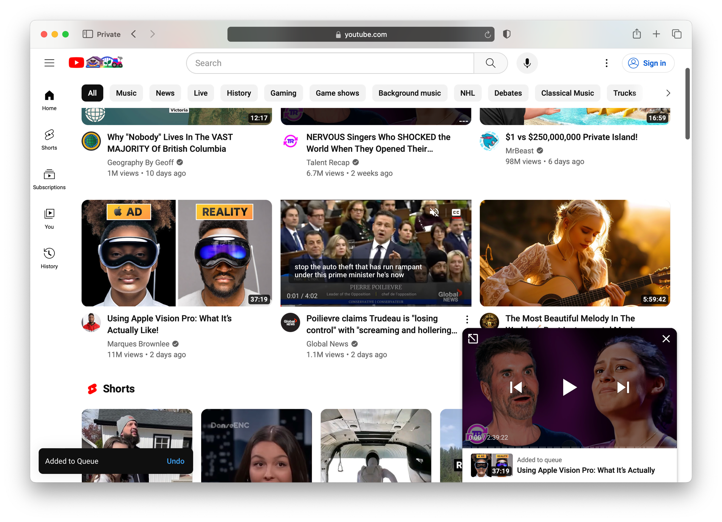

Appendix 3

Appendix 4

Appendix 5

Appendix 6

Appendix 7

Appendix 8

